Dear Parent,

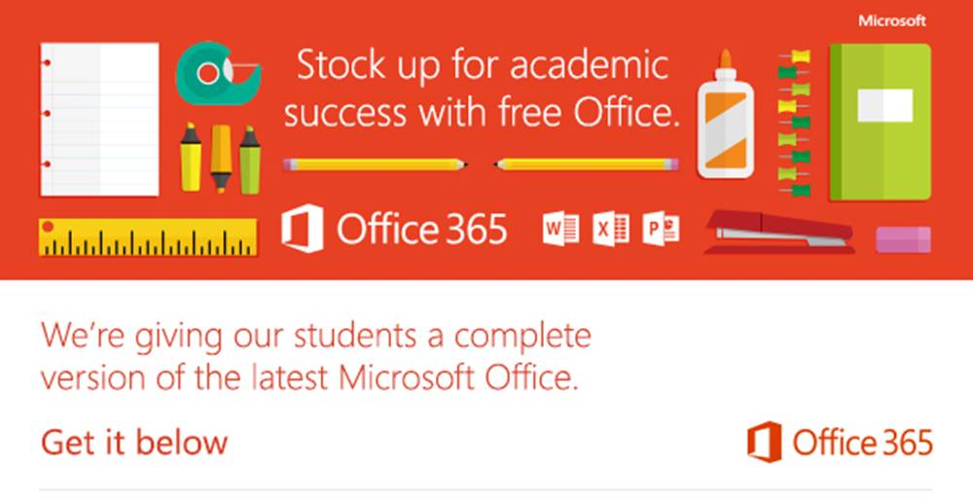

In order to help our students prepare for success this school year, we’re providing Office to every student free of charge. With Office 365, your child will now have access to the latest version of Word, for writing; Excel, for spreadsheets; PowerPoint, for presentations; OneNote, for organization and note taking; and much more.

* Install on up to 5 compatible PCs and Macs, plus 5 tablets (including iPad!)
* Use with OneDrive for automatic device syncing
* Gain valuable skills on the world’s most popular productivity software
* Office subscription lasts for as long as your child is a student and the program continues

To get Office follow these simple steps:

1. For PC and Mac:
   1. Visit <http://portal.office.com>
      * Sign in with C2k username in the format[username@c2ken.net](mailto:username@c2ken.net)
      * Use your normal C2k password
   2. On the installation page select your language and click install
2. For iOS and Android:
   1. Download from your app store

* iPad: [Word](http://office.microsoft.com/en-us/mobile/redir/XT104180215.aspx), [Excel](http://office.microsoft.com/en-us/mobile/redir/XT104180216.aspx), [PowerPoint](http://office.microsoft.com/en-us/mobile/redir/XT104180217.aspx)
* [iPhone](http://office.microsoft.com/en-us/mobile/redir/XT104168003.aspx)
* [Android](http://office.microsoft.com/en-us/mobile/redir/XT104168016.aspx)
  1. Sign in with your C2k username and password for full editing capability

Please note, the username must be in the format username@c2ken.net.

Yours Sincerely,

Mrs Thompson

Principal