**Welcome to P1/2!**



Dear Parents and children,

My name is Miss Miller and I will be your teacher. Mrs Rea is our classroom assistant.We are looking forward to seeing you all next week.

Our school year for **P2-7 will commence Tuesday 24th August**. In order to help the P1 children become familiar with the routine of the school, the class has been divided into 2 groups and each individual group will have its own settling in morning and then they will all come together on Friday 27th August. This will make settling in easier and will allow the children to get to know each other.

Group 1’s **settling in day** will be on **Wednesday 25th August** and they should attend from **9am – 12:15pm.**

Group 2’s **settling in day** will be on **Thursday 26th August** and they should attend from **9am – 12:15pm.**

On **Friday 27th August**. from **9am – 12:15pm all children in P1/2** will be in together. Then they are **off** again on **Monday 30th August** for the Bank Holiday and then everyone is back on **Tuesday 31st August, 9-12:15pm**.

In order to help the children settle well into school life the P1 children will have a shorter day up until Halloween. Details of times are given below. This gradual build-up to the full school day allows each child to become familiar with lots of new situations. Experience has shown that this helps the children settle into school happily – something we all want to see!

Timetable for the First Term:

|  |  |
| --- | --- |
| Tue 24th Aug | P2-7 start back, 9am -12:15pm |
| Wed 25th Aug | P2 and P1 Group 1-settling in morning,  9am -12:15pm |
| Thurs 26th Aug | P2 and P1 Group 2-settling in morning,  9am -12:15pm |
| Fri 27th Aug | All of P1 and P2, 9am -12:15pm |
| Mon 30th Aug (Bank Holiday) | No school |
| Tue 31stAug – Fri 22nd Oct | P1 -9 am – 12:15pm  P2-9am -2pm |
| Mon 25th Oct – Mon 1st Nov | Half-term Break |
| Tue 2rd Nov - onwards | 9 am – 2.00 pm (staying for lunch) |

**Drop off** is **from 8:45am until 9am**. Parents are to walk the P1/2 children around to the **emergency exit door of the P1/2 classroom** where I will greet them. Children must be in school **by 9am** and if they are **late** they should go into school **via the front door,** reporting to the office.

There will be a **supervision club** from **8:15 – 8:45 am** and children need to be **booked** into this using **School Money**. It is £1 per day.

**Pick up** for P1/2 will be **from the P1/2 classroom emergency exit door**. Please remember to **park appropriately** outside school and please remember to maintain **social distancing** and **keep to the right.**

**Please let me know if someone different is picking up your child.**

**School Day**

Due to DE Guidance we are maintaining the school bubbles therefore the P1/2 children will be playing separately from other bubbles.

8:45am Drop off



9am School day starts

10:20am Break

10:30am Outside play

12:15 P1 hometime (until Halloween)

12:30pm Lunch

12:45pm Outside play

2pm P2 hometime

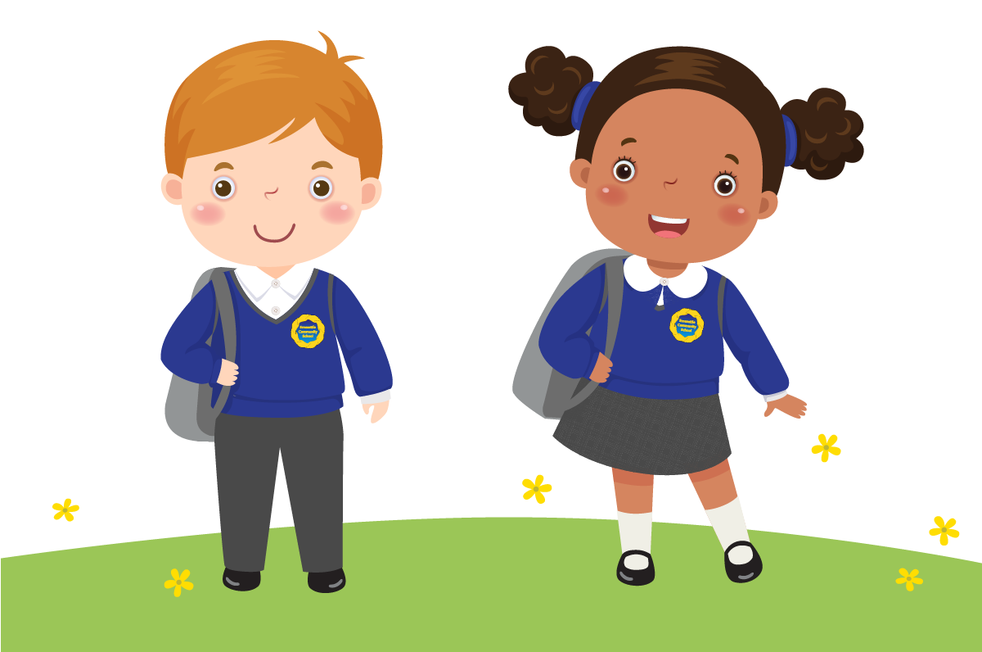

**School Uniform**

The children should wear:

White polo shirt with school logo

Red sweatshirt with school logo

Grey trousers / grey skirt

Red school coat with school logo is optional

White / grey socks (boys and girls) or red / grey tights (girls)

Black shoes

School Bag (These are available from school for £7.20)

Uniform can be purchased from: School Days, 2 High Street, Newtownards.

Telephone : 028 91827717 or order online [www.schooldaysltd.co.uk](http://www.schooldaysltd.co.uk)

If you feel your child is entitled to a uniform grant, please complete the form provided by the Education Authority, which will be available on their website.

**PE**

Your child will need a pair of **black P.E. slippers**. These should be **named** and **kept in school on their peg** in a **drawstring bag** along with a **spare pair of pants**. On **PE days**, currently **Wednesday** and **Friday**, the children should come to school **wearing black jogging bottoms and black or white trainers, along with their school polo shirt and sweatshirt**.

**All items of clothing MUST be named.**

**Break Time**

Children are encouraged to eat a **healthy break** in class, **Monday to Thursday**. **Friday** is the one day in the week where they can enjoy a **small treat** such as a wrapped biscuit. **(No sweets)** One or two small items are enough as the children only have 10 minutes to eat.

Milk will no longer be available. All children are encouraged to **drink water** and should bring it in a **named water bottle**. **(No juice)**

**Please continually check that your child’s bottle is not leaking and is always closed properly to avoid spills. DO NOT put water bottles inside the red school bag as if it leaks it could damage school books.**

**Lunch Time**

**School Dinners** are served daily in the **canteen** at a cost of **£2.60**, starting **Wednesday 1st September** and should be **booked via School Money.**

Children who prefer a **packed lunch** are supervised in their classroom.

If you are entitled to free school meals then **please claim them as the school receives extra money in the budget.** The child does not need to take them.

**Allergies**

We are a **nut free school** as we do have some children with **severe allergies.**

**Illness**

If your child is ill they should remain at home.

If they are well enough to attend school, but need to take medicineplease fill in an ‘Administration of Medicine’ form and hand it to Mrs Thompson/Mrs Rea as you drop your child off at school. **Please note medicines cannot be administered without this consent.**

Please email the school on [info@Loughriesips.newtownards.ni.sch.uk](mailto:info@Loughriesips.newtownards.ni.sch.uk) to inform us if your child is ill on the first day of absence. Please also ring should they have a dental or a doctor’s appointment during the school day.

If anyone in your family is showing symptoms of Coronavirus, then do not send your child to school. Follow the current advice on the Public Health Agency website: [www.publichealth.hscni.net](http://www.publichealth.hscni.net/)

**Concerns**

If you have a worry or concern about your child and need to talk to me, please send in a note or speak to me at the start or end of the school day at pick-up time. This will have to be a very brief chat but if we need a longer chat I can organise that for another suitable time. Alternatively, ring the school office and Mrs Emery will organise a suitable time for us both.

I am the Designated Child Protection Teacher and Mr Stewart is the Deputy Designated Child Protection Teacher.

**P1/2 Curriculum**

* Structured Play
* Linguistic Phonics
* Mental, practical and written Maths including problem solving
* Reading, Writing and Talking and Listening activities
* PDMU and RE
* World around Us
* Creative Arts – Drama, Music and Art
* PE -Athletics/Dance/ Games/ Gymnastics

The Foundation Stage (P1/2) is all about developing the WHOLE child physically, emotionally, intellectually, socially and spiritually. Some aspects of P1/2 include:

* Learning through Play
* Learning through Topics
* Practical Maths activities
* Talking and listening
* Language and Literacy games
* Thinking Skills and Personal Capabilities

**Topics**

**We follow a two year rolling curriculum of topics in P1/2. This year’s topics are:**

* Teddy Bears
* Autumn
* Toys
* Christmas
* Food
* Winter
* Growing
* Spring
* Animals
* Summer

**Helping your child learn**

* Read together
* Talk to and listen to your child
* Let your child practise using writing and drawing implements and scissors
* Teach them nursery rhymes
* Encourage playing with construction toys and doing puzzles
* Talk about colours, shapes and count objects

**Homework**

P1 will not start formal homeworks initially but may have a Nursery Rhyme Box /Wordless Book sent home.

Homework will be **sent home** in a plastic homework bag on **Monday** and should be **returned** to school on **Thursday**. It consists of Reading, words, Mental Maths and two written or practical homeworks.

**ALL Reading Books should be returned on the Thursday inside the plastic homework bag so that they can be used by another child.**

On **Thursday** night the children will take home a **topic book** which should be **returned** to school on **Friday** morning.

**What to bring**

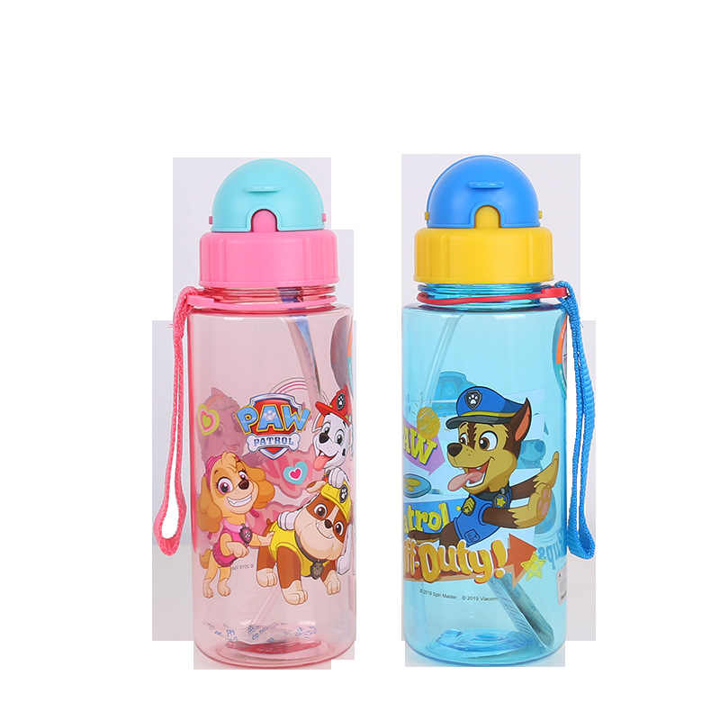

**Every day** your child will need to bring

* coat
* red Loughries school bag (can be purchased in school for £7.20)
* lunchbox containing their healthy break / lunch
* water bottle containing water

**On the first day please bring a named drawstring bag containing a spare pair of pants and a pair of black PE gutties to hang on their peg and remain in school.**

**Extra Resources**

During the year you will be asked to supply some extra resources for our classroom such as tissues, wipes and Pritt Stick glue (approximately 2 per term).

**Please send in two Pritt Stick glues 22g or 43g asap.**

**Website**

Check our website for up to date information - [www.loughriesips.com](http://www.loughriesips.com/)

There is a texting service in use for emergencies so please check we have up to date contact numbers.

**Toys**

We have toys in school. **We ask children to leave their toys at home and play with all the P1/2 toys when they are in school**. When children bring toys to school it can cause upset if others want to see the toy or play with it. Children then become even more upset if something gets lost or broken.

**Parent/ Teacher Interviews**

We are **hopeful** we can have **face to face** parent / teacher interviews this year. These have been scheduled for the week beginning **Monday 18th October** and **Monday 7th February.** These are times when we can discuss your child’s progress. More details will be given nearer the time.

**Your Job**

1. **Use positive words**

Your feelings will guide your child’s emotions. Approach school in a positive way. Don’t pass on any negative memories of your school days.

1. **Routine**

If your child's in holiday routine - staying up late and rising late - then begin to change their schedule. Gradually bring their bedtime back to a time suitable for school nights and introduce more regular eating habits with meals at set times.

1. **Encourage a good breakfast**

Children learn better with a full tummy from a nutritious breakfast.

1. **Label all belongings and clothing**

There are 29 children in P1/2 this year and most school jumpers look the same and are easily mixed up.

1. **Drop off and collection**

Encourage your child to come into the classroom independently and be there early to collect. Let your child and teacher know who is collecting them. I will only let them out when I see someone for them.

1. **Be organised**

Please check your child’s school bag and homework for notes and make sure they have everything they need. This will make school less stressful for your child and helps them to learn independence skills.

**Most importantly…**

We want your child to be happy and well settled in school. Only when a child is happy can learning take place. We hope that Loughries IPS will be a place where your child will learn, integrate, participate and succeed! We look forward to working with you and your child and watching them blossom.

Normally, this information is shared at face to face meetings and you are able to ask questions. Therefore if you have any questions or concerns please feel free to contact me via email on [kmiller954@c2kni.net](mailto:kmiller954@c2kni.net).

Have a lovely weekend and we are looking forward to seeing you next week,

Miss Miller and Mrs Rea